ASSIGNMENT 3 – BANKING ASSIGNMENT

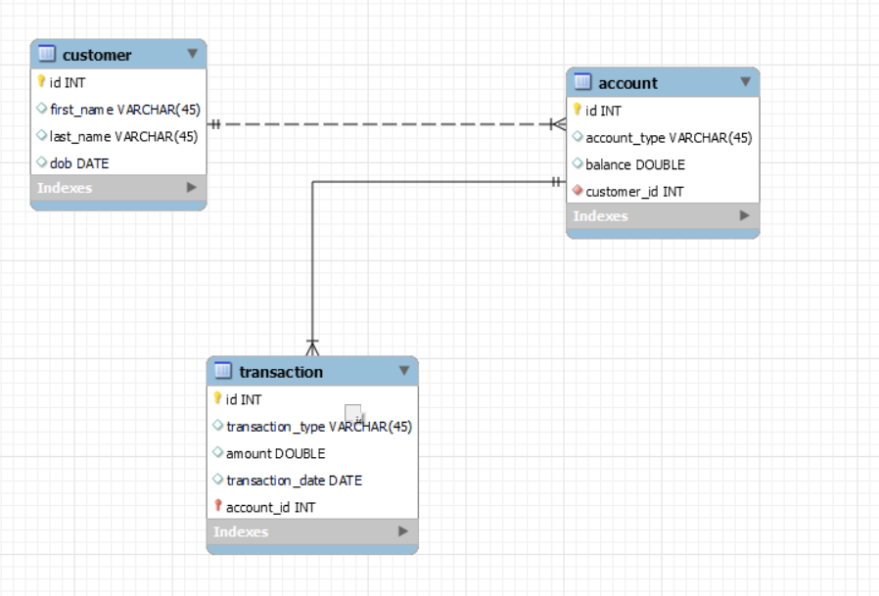

-- MySQL Workbench Forward Engineering

-- -----------------------------------------------------

-- Schema bank_hex_feb_24

-- -----------------------------------------------------

-- -----------------------------------------------------

-- Schema bank_hex_feb_24

-- -----------------------------------------------------

CREATE SCHEMA IF NOT EXISTS `bank_hex_feb_24` DEFAULT CHARACTER SET utf8 ;

USE `bank_hex_feb_24` ;

-- -----------------------------------------------------

-- Table `bank_hex_feb_24`.`customer`

-- -----------------------------------------------------

CREATE TABLE IF NOT EXISTS `bank_hex_feb_24`.`customer` (

`id` INT NOT NULL AUTO_INCREMENT,

`first_name` VARCHAR(45) NULL,

`last_name` VARCHAR(45) NULL,

`dob` DATE NULL,

PRIMARY KEY (`id`))

ENGINE = InnoDB;

-- -----------------------------------------------------

-- Table `bank_hex_feb_24`.`account`

-- -----------------------------------------------------

CREATE TABLE IF NOT EXISTS `bank_hex_feb_24`.`account` (

`id` INT NOT NULL AUTO_INCREMENT,

`account_type` VARCHAR(45) NULL,

`balance` DOUBLE NULL,

`customer_id` INT NOT NULL,

PRIMARY KEY (`id`),

INDEX `fk_account_customer_idx` (`customer_id` ASC) ,

CONSTRAINT `fk_account_customer`

FOREIGN KEY (`customer_id`)

REFERENCES `bank_hex_feb_24`.`customer` (`id`)

ON DELETE NO ACTION

ON UPDATE NO ACTION)

ENGINE = InnoDB;

-- -----------------------------------------------------

-- Table `bank_hex_feb_24`.`transaction`

-- -----------------------------------------------------

CREATE TABLE IF NOT EXISTS `bank_hex_feb_24`.`transaction` (

`id` INT NOT NULL AUTO_INCREMENT,

`transaction_type` VARCHAR(45) NULL,

`amount` DOUBLE NULL,

`transaction_date` DATE NULL,

`account_id` INT NOT NULL,

PRIMARY KEY (`id`, `account_id`),

INDEX `fk_transaction_account1_idx` (`account_id` ASC) ,

CONSTRAINT `fk_transaction_account1`

FOREIGN KEY (`account_id`)

REFERENCES `bank_hex_feb_24`.`account` (`id`)

ON DELETE NO ACTION

ON UPDATE NO ACTION)

ENGINE = InnoDB;

#Insertions

use bank_hex_feb_24;

show tables;

insert into customer(first_name,last_name,dob) values

('harry','potter','2002-03-21'),

('ronald','weasley','2001-02-10'),

('hermione','granger','2002-11-15');

insert into account(account_type,balance,customer_id) values

('savings',50000,1) ,

('current',120000,2) ,

('zero_balance',100000,3),

('current',150000,1) ,

('savings',30000,3);

--------------------------------------------------

Database changed

| Tables_in_bank_hex_feb_24 |

| account |

| customer |

| transaction |

---------------------------------------------------

insert into transaction(transaction_type,amount,transaction_date,account_id)

values

('deposit', 10000, '2024-02-01',1),

('withdrawal', 5000, '2024-02-02',1),

('deposit', 20000, '2024-02-02',2),

('withdrawal', 8000, '2024-02-02',3),

('transfer', 20000, '2024-02-01',4),

('transfer', 7000, '2024-02-05',5);

Describe customer;

+------------+-------------+------+-----+---------+----------------+

| Field | Type | Null | Key | Default | Extra |

+------------+-------------+------+-----+---------+----------------+

| id | int(11) | NO | PRI | NULL | auto_increment |

| first_name | varchar(45) | YES | | NULL | |

| last_name | varchar(45) | YES | | NULL | |

| dob | date | YES | | NULL | |

insert into account(account_type,balance,customer_id) values

('savings',50000,1) ,

('current',120000,2) ,

('zero_balance',100000,3),

('current',150000,1) ,

('savings',30000,3);

describe account;

+--------------+-------------+------+-----+---------+----------------+

| Field | Type | Null | Key | Default | Extra |

+--------------+-------------+------+-----+---------+----------------+

| id | int(11) | NO | PRI | NULL | auto_increment |

| account_type | varchar(45) | YES | | NULL | |

| balance | double | YES | | NULL | |

| customer_id | int(11) | NO | MUL | NULL | |

+--------------+-------------+------+-----+---------+----------------+

insert into transaction(transaction_type,amount,transaction_date,account_id)

values

('deposit', 10000, '2024-02-01',1),

('withdrawal', 5000, '2024-02-02',1),

('deposit', 20000, '2024-02-02',2),

('withdrawal', 8000, '2024-02-02',3),

('transfer', 20000, '2024-02-01',4),

('transfer', 7000, '2024-02-05',5);

describe transaction;

+------------------+-------------+------+-----+---------+----------------+

| Field | Type | Null | Key | Default | Extra |

+------------------+-------------+------+-----+---------+----------------+

| id | int(11) | NO | PRI | NULL | auto_increment |

| transaction_type | varchar(45) | YES | | NULL | |

| amount | double | YES | | NULL | |

| transaction_date | date | YES | | NULL | |

| account_id | int(11) | NO | PRI | NULL | |

+------------------+-------------+------+-----+---------+----------------+

**TASK 2**

-- 1. Write a SQL query to retrieve the name, account type and email of all customers.

select c.first_name,a.account_type

from customer c, account a;

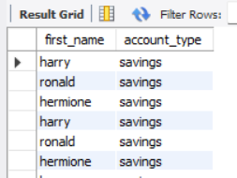

-- 2. write a sql query to list all transaction corresponding customer.

select c.first_name,c.last_name,t.transaction_type,t.transaction_date

from customer c join account a on c.id=a.customer_id join transaction t on a.id=t.account_id;

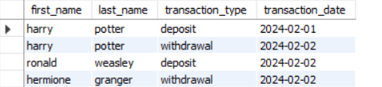

-- 3. write a sql query to increase the balance of a specific account by a certain amount.

update account

set balance = balance + 100

where id=1;

--- code is executed but no output shown

-- 4. write a sql query to combine first and last names of customers as a full_name.

select id, first_name,last_name,

concat(first_name, ' ', last_name) as full_name

from bank_hex_feb_24.customer;

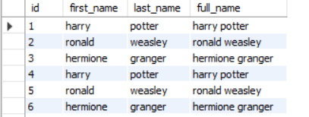

-- 5. write a sql query to remove accounts with a balance of zero where the account type is savings.

delete from bank_hex_feb_24.account

where balance = 0 and account_type = 'savings';

-- 6. write a sql query to find customers living in a specific city.

select id, first_name, last_name

from bank_hex_feb_24.customer

where city = 'yourcityname';

-- 7. write a sql query to get the account balance for a specific account.

select balance from bank_hex_feb_24.account where id = 1;

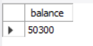

-- 8. write a sql query to list all current accounts with a balance greater than $1,000.

select id, account_type, balance

from bank_hex_feb_24.account

where account_type = 'current'

and balance > 1000;

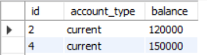

-- 9. write a sql query to retrieve all transactions for a specific account.

select id, transaction_type, amount, transaction_date

from bank_hex_feb_24.transaction

where account_id = 123;

-- 10. write a sql query to calculate the interest accrued on savings accounts based on a given interest rate.

select id, account_type, balance,

balance * 0.05 as interest_accrued

from bank_hex_feb_24.account

where account_type = 'savings';

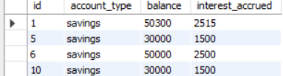

-- 11. write a sql query to identify accounts where the balance is less than a specified overdraft limit.

select id, account_type, balance

from bank_hex_feb_24.account

where balance < -500;

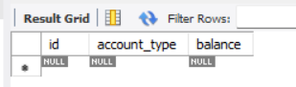

-- 12. write a sql query to find customers not living in a specific city.

select id, first_name, last_name

from bank_hex_feb_24.customer

where city != 'yourcityname'

or city is null;

**task 3**

--- 1. write a sql query to find the average account balance for all customers. */

select customer_id, avg(balance)

from account

group by customer_id;

o/p:

+-------------+--------------+

| customer_id | avg(balance) |

+-------------+--------------+

| 1 | 100000 |

| 2 | 120000 |

| 3 | 65000 |

+-------------+--------------+

2. write a sql query to retrieve the top 10 highest account balances.

select balance

from account

order by balance desc

limit 0,3;

3. write a sql query to calculate total deposits for all customers in specific date. also display name of the customer

select c.first_name,c.last_name,t.transaction_type, t.amount, t.transaction_date

from transaction t join account a on a.id = t.account_id join customer c on c.id = a.customer_id

where t.transaction_date = '2024-02-02' and t.transaction_type='withdrawal';

4. write a sql query to find the oldest and newest customers. */

(select first_name,dob,'oldest' as status from customer order by dob limit 0,1)

union

(select first_name,dob,'youngest' as status from customer order by dob desc limit 0,1);

o/p:

+------------+------------+----------+

| first_name | dob | status |

+------------+------------+----------+

| ronald | 2001-02-10 | oldest |

| hermione | 2002-11-15 | youngest |

+------------+------------+----------+

5. write a sql query to retrieve transaction details along with the account type.

select

t.id as transaction_id, t.transaction_type, t.amount,

t.transaction_date, t.account_id, a.account_type

from bank_hex_feb_24.transaction t

join bank_hex_feb_24.account a on t.account_id = a.id;

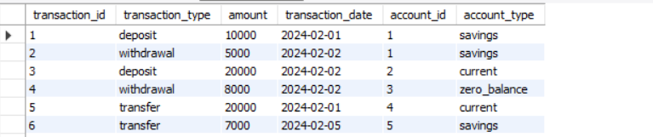

6. write a sql query to get a list of customers along with their account details.

select

c.id as customer_id , c.first_name, c.last_name, c.dob,

a.id as account_id, a.account_type, a.balance

from bank_hex_feb_24.customer c

join bank_hex_feb_24.account a on c.id = a.customer_id;



7. write a sql query to retrieve transaction details along with customer information for a

specific account.

select t.id as transaction_id, t.transaction_type, t.amount, t.transaction_date,

a.id as account_id, a.account_type, a.balance,

c.id as customer_id, c.first_name, c.last_name, c.dob

from bank_hex_feb_24.transaction t

join bank_hex_feb_24.account a on t.account_id = a.id

join bank_hex_feb_24.customer c on a.customer_id = c.id

where a.id = <your_account_id>;

8. write a sql query to identify customers who have more than one account.

select c.first_name,count(c.id) as number_of_accounts

from customer c join account a on c.id = a.customer_id

-- where count(c.id) > 1 - 0 invalid use of group function

group by a.customer_id

having number_of_accounts>1;

/*

a.customer_id=1 (2)

1 harry potter 2002-03-21 1 savings 50000 1

1 harry potter 2002-03-21 4 current 150000 1

a.customer_id=2 (1)

2 ronald weasley 2001-02-10 2 current 120000 2

a.customer_id=3 (2)

3 hermione granger 2002-11-15 3 zero_balance 100000 3

3 hermione granger 2002-11-15 5 savings 30000 3

*/

9. write a sql query to calculate the difference in transaction amounts between deposits and

withdrawals.

select max(amount) - min(amount) as difference

from

((select transaction_type ,sum(amount) as amount, 'deposit' as op

from transaction

where transaction_type ='deposit' )

union

(select transaction_type , sum(amount) as amount, 'withdrawal' as op

from transaction

where transaction_type ='withdrawal')) as t;

10. write a sql query to calculate the average daily balance for each account over a specified period.

select a.id as account_id, a.account_type,

avg(daily_balance) as avg_daily_balance

from (

select a.id, a.account_type,

date(t.transaction_date) as transaction_date,

sum(case

when t.transaction_type = 'credit' then t.amount

else -t.amount

end) as daily_balance

from bank_hex_feb_24.account a

join bank_hex_feb_24.transaction t on a.id = t.account_id

where t.transaction_date between 'start_date' and 'end_date'

group by a.id, a.account_type,

date(t.transaction_date)

) as daily_balances

group by

account_id,

account_type;

11. calculate the total balance for each account type.

select account_type,

sum(balance) as total_balance

from bank_hex_feb_24.account

group by account_type;

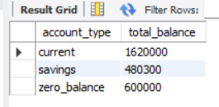

12. identify accounts with the highest number of transactions order by descending order.

select a.id as account_id,

count(t.id) as num_transactions

from bank_hex_feb_24.account a

join bank_hex_feb_24.transaction t on a.id = t.account_id

group by a.id

order by num_transactions desc;

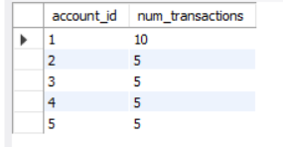

13. list customers with high aggregate account balances, along with their account types.

select c.id as customer_id, c.first_name, c.last_name, a.account_type,

sum(a.balance) as total_balance

from bank_hex_feb_24.customer c

join bank_hex_feb_24.account a on c.id = a.customer_id

group by c.id, a.account_type

order by total_balance desc;

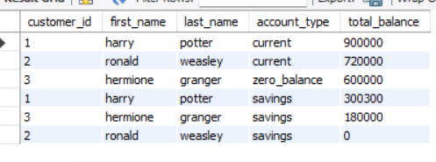

14. Identify and list duplicate transactions based on transaction amount, date, and account

select t.amount, t.transaction_date, t.account_id,

count(*) as num_duplicates

from bank_hex_feb_24.transaction t

group by t.amount, .transaction_date, t.account_id

having count(*) > 1;